**Make an E-commerce Website for Kitchen Story food items**

**Projection Description:**

As a Full Stack Developer, complete the features of the application by planning the development and pushing the source code to the GitHub repository. 

**Background of the problem statement:**

Kitchen Story is an e-commerce portal that lets people shop basic food items on their website. The website needs to have the following features:

* A search form in the home page to allow entry of the food items to be purchased by the customer.
* Based on item details entered, it will show available food items with price.
* Once a person selects an item to purchase, they will be redirected to the list of available items. In the next page, they are shown the complete breakout of the order and details of the payment to be made in the payment gateway. When payment is done, they are shown a confirmation page with details of the order.

**The website needs to have the following features:**

You’re asked to develop a prototype of the application. It will be then presented to the relevant stakeholders for budget approval. Your manager has set up a meeting where you’re asked to do the following:

* Admin login page where admin can change password after login if he wants to
* A master list of food items available for purchase
* A functionality to add or remove food items

**Project Users Stories**

As a full stack developer, I want to develop kitchen story ecommerce website which list out products for purchase,

* As a user , I want register as a buyer to login and purchase the products.
* As a user, I want a website to purchase kitchen products.
* As a user, I want to login using login page and enter the welcome page.
* As a user, I want to see list of food items available and add products to cart.
* As a user, I want to checkout cart items and make a purchase.
* As an admin, I want to login and add products.
* As an admin, I want to maintain the products.
* As an admin, I want to list available products.
* As a developer, I want to build front-end web-application for buyers to login and view the list of products available.
* As a developer, I want to build front-end web-application for buyers to select products add to cart and checkout to make purchase of items.
* As a developer, I want to provide option for logout.
* As a developer, I want to build front-end web-application for admin user to add and maintain the food products.
* As a developer, I want to provide option for logout.

**Sprint 1 (Week 1)**

* As a developer, I want to build front-end web-application for buyers to login and view the list of products available.
* As a developer, I want to build front-end web-application for buyers to select products add to cart and checkout to make purchase of items.
* As a developer, I want to provide option for logout.
* As a developer, I want to build front-end web-application for admin user to add and maintain the food products.
* As a developer, I want to provide option for logout.

**Sprint 2 (Week 2)**

* Testing the front-end application with different kinds of User input.
* Initializing git repository to track changes as development progresses.
* Pushing code to GitHub.
* Creating this specification document with application details, appearance, and user interactions.

## **Core concepts used in project**

* + - HTML, CSS, Typescript and bootstrap.
    - Angular.

**Architecture diagram / flow chart:**

**User Operations,**

**Start**

**User registers account as buyer and logs into the web application.**

**If user account is created, user logs into his account successfully and performs operations.**

**List of available food items are listed for purchase. User selects the product and adds to cart and make a purchase of selected items.**

**User should be able to logoff successfully from the application.**

**End**

**Admin Operations,**

**Start**

**Admin registers account as admin and logs into the web application.**

**Admin logs into his account successfully and creates and performs product maintenance operations.**

**User should be able to logoff successfully from the application.**

**End**

**Screenshots,**

* Json- Server is the internal built server available within angular for testing web applications.
* List of products, admin user, buyers are updated into the system.

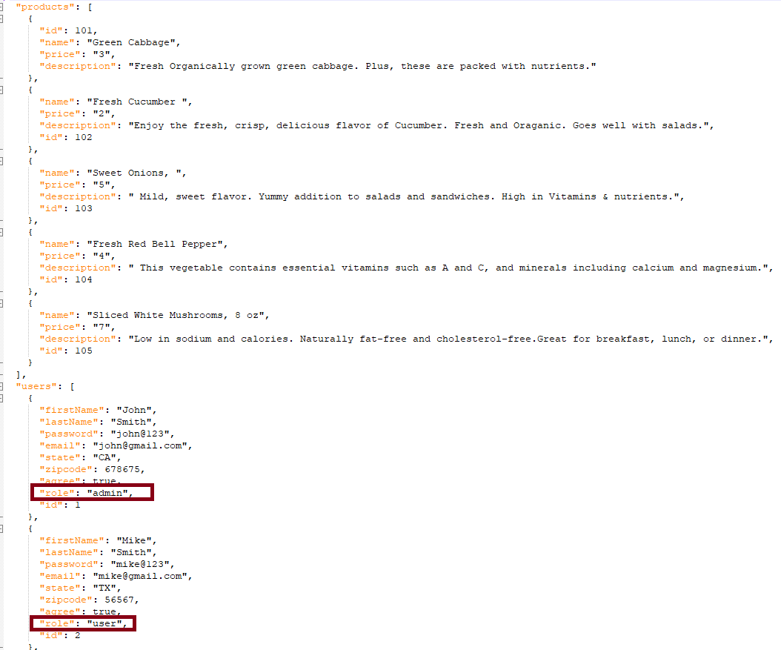

* Run JSON Server,

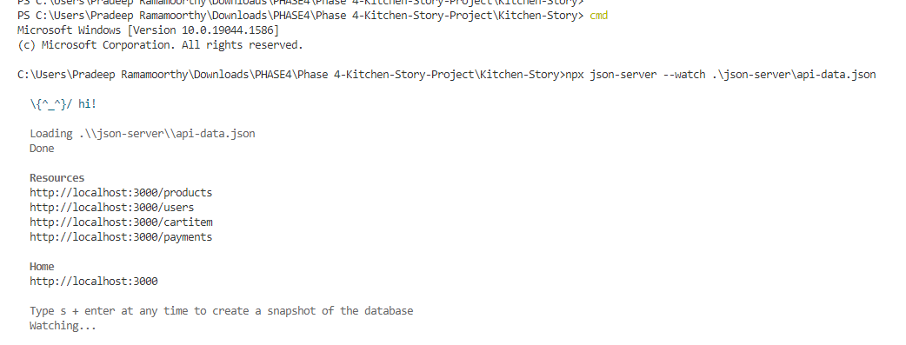

* Run kitchen story app server,

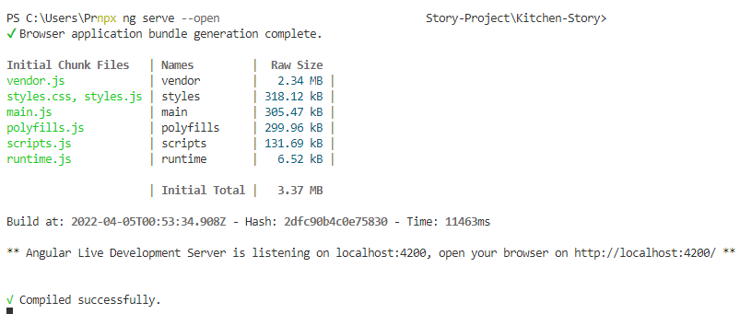

* Register as “admin” user.

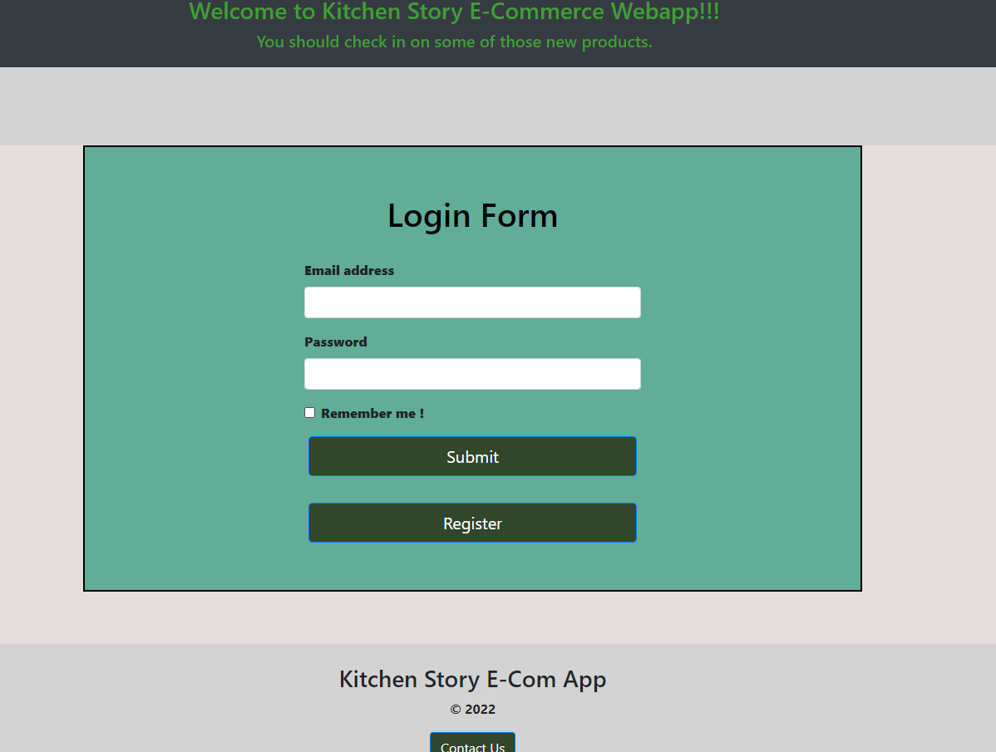

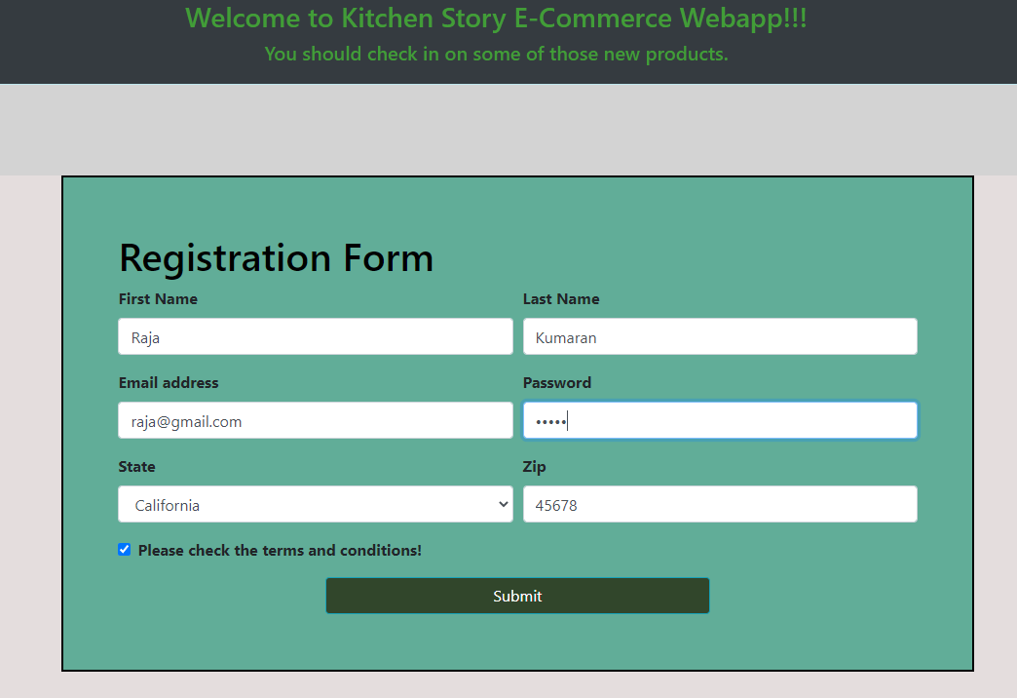

* admin registered in the system,

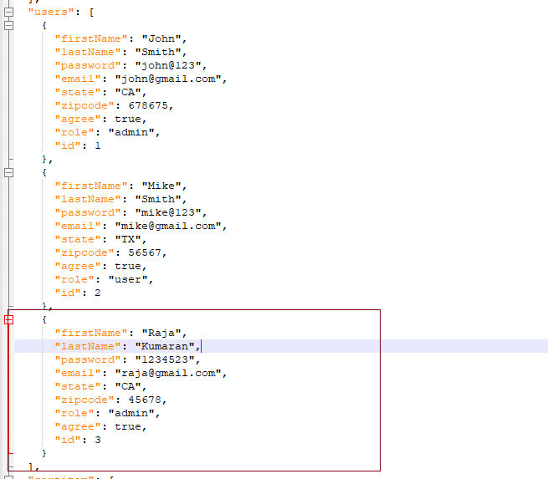

* Admin login form validations,

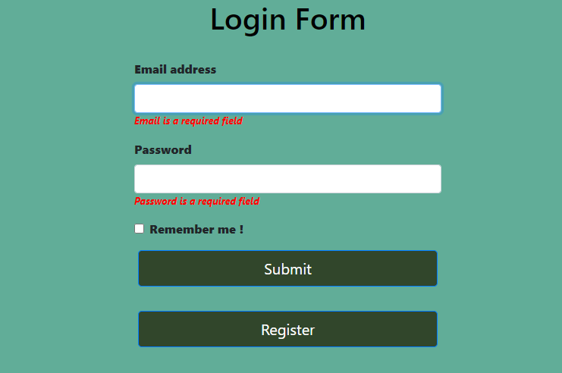

* Admin logs into the application,

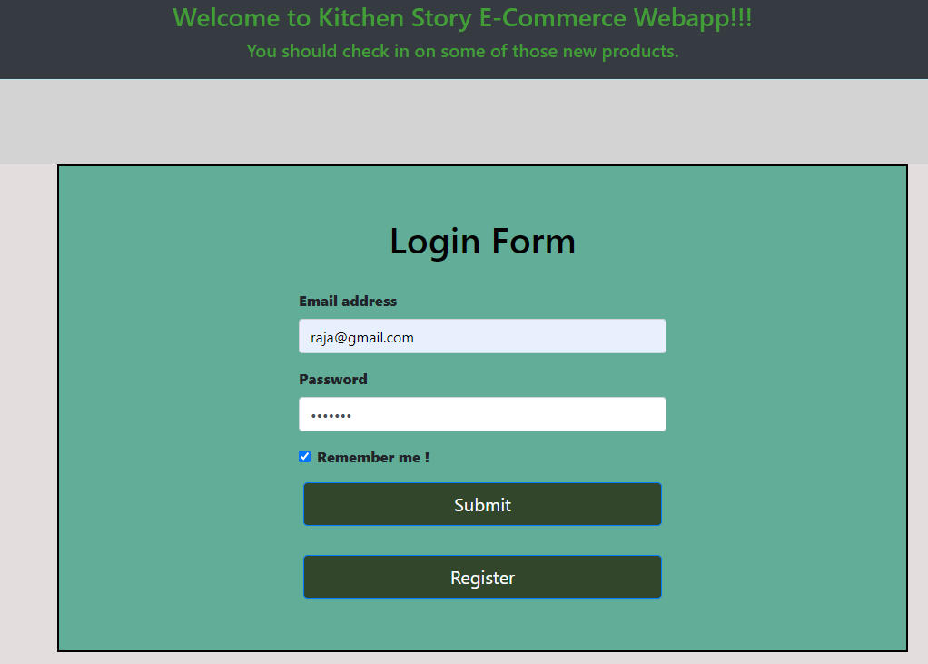

* Admin home Page,

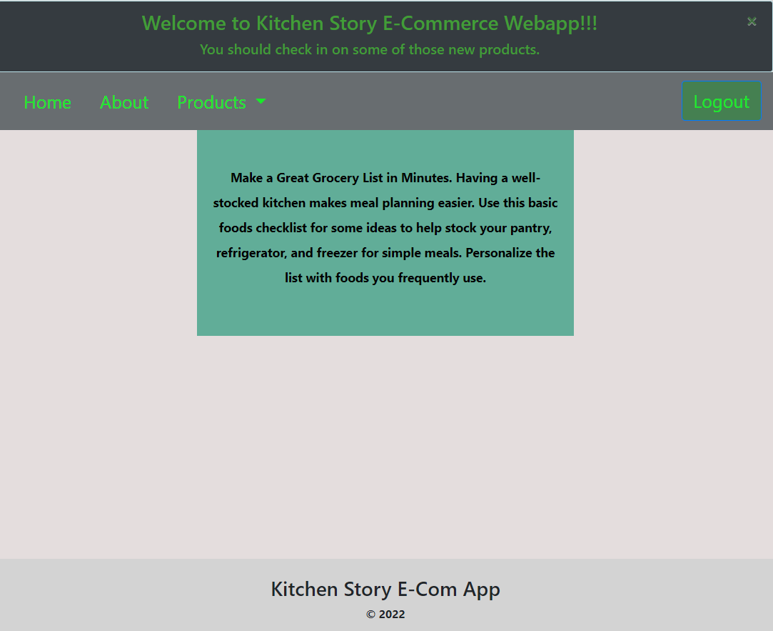

* Admin about Page,

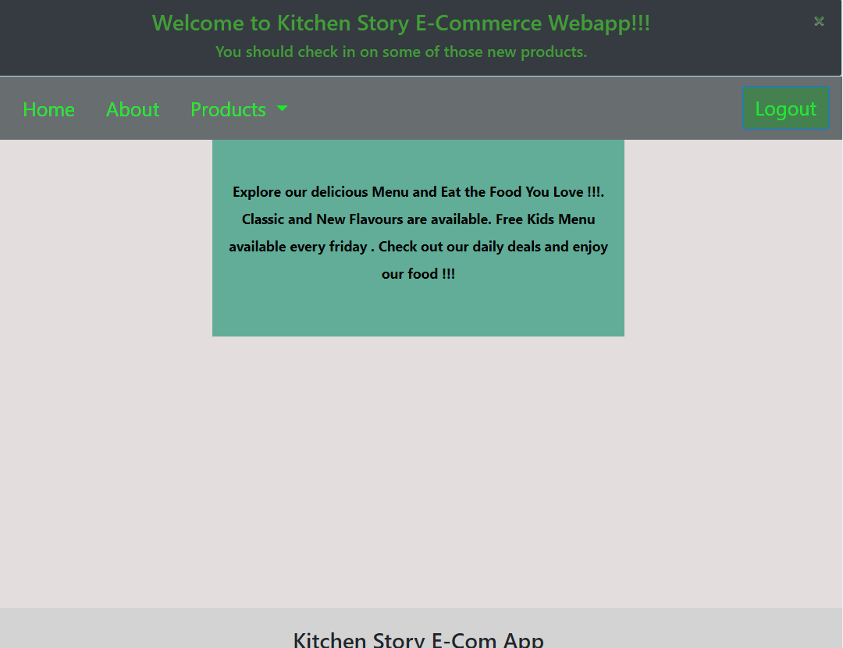

* Upon clicking Product, available list of products is displayed.

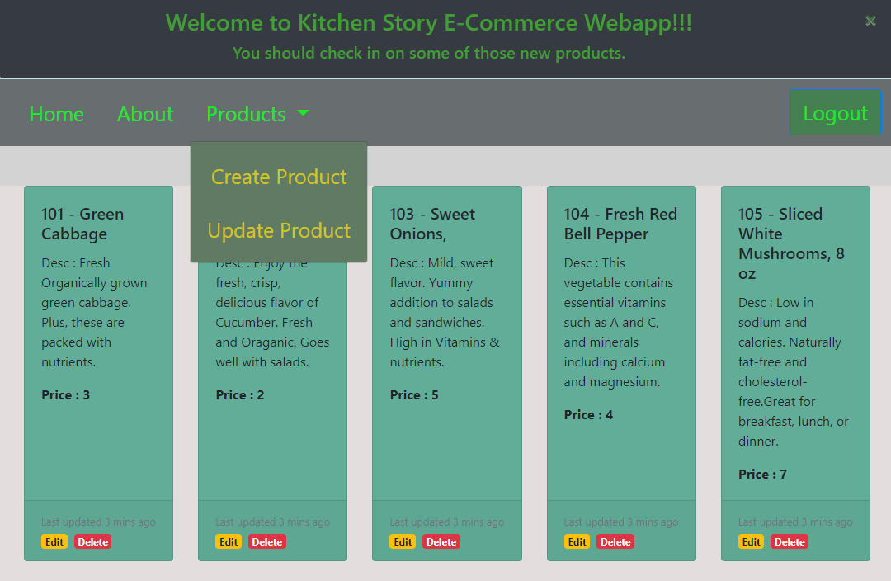

* Create Product,

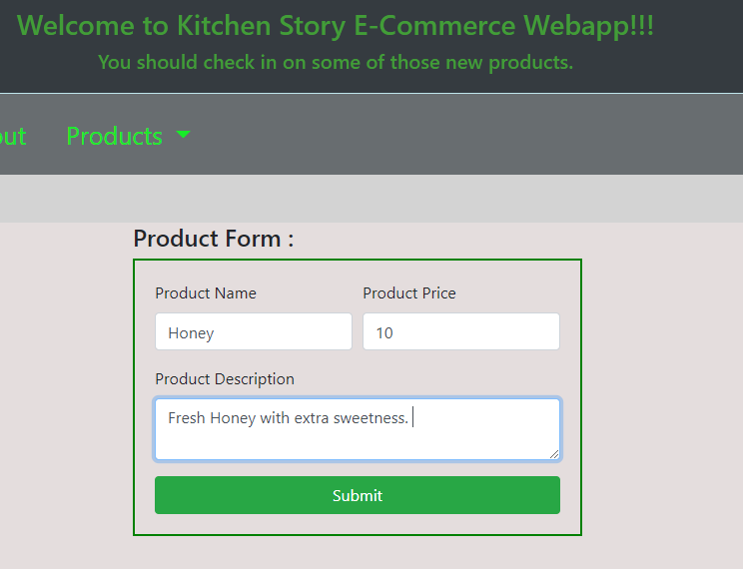

* Products gets displayed under product list,

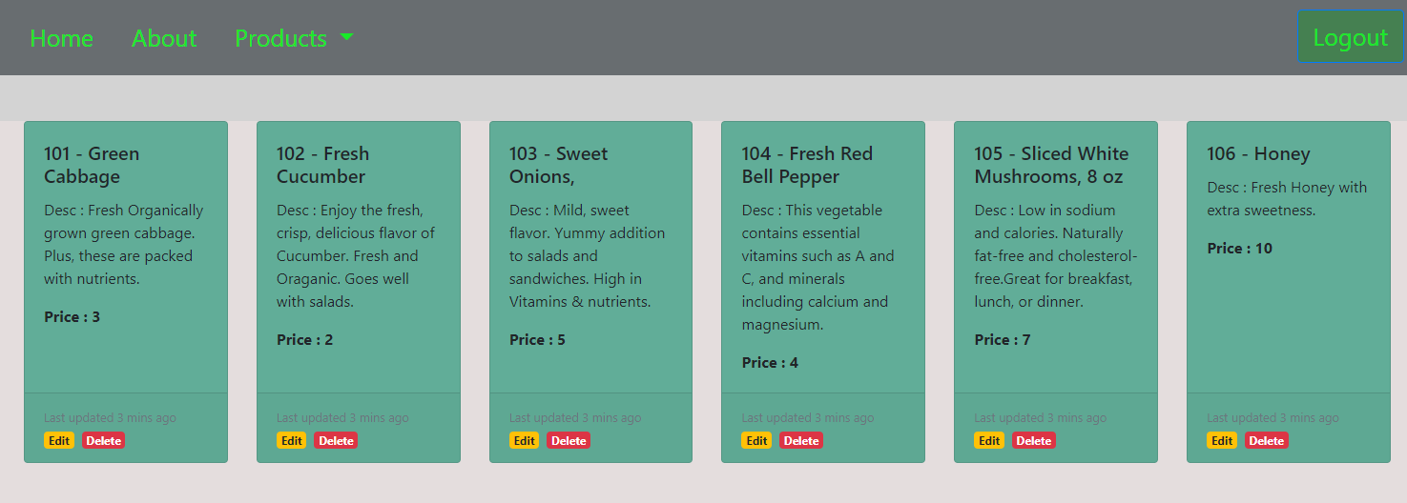

* Update existing product in the system.

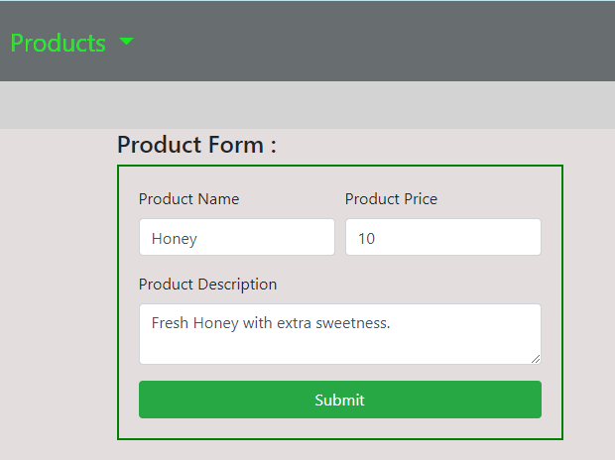

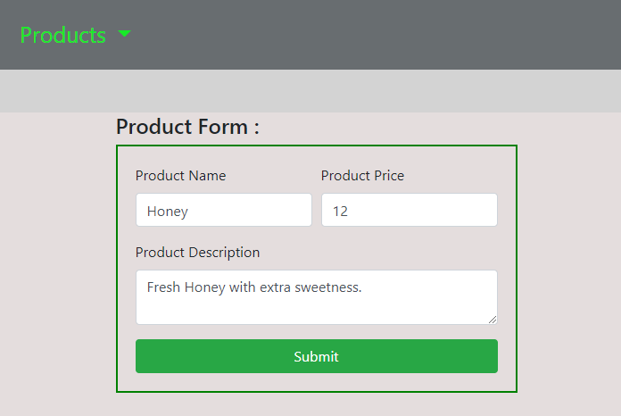

* Product has been updated and listed with the updated price.

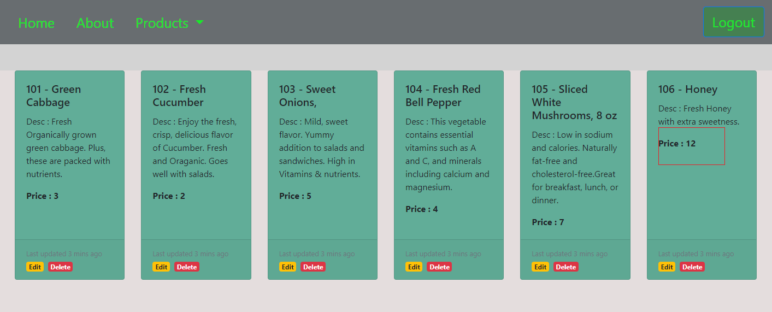

* Product deletion removes the product form the system.

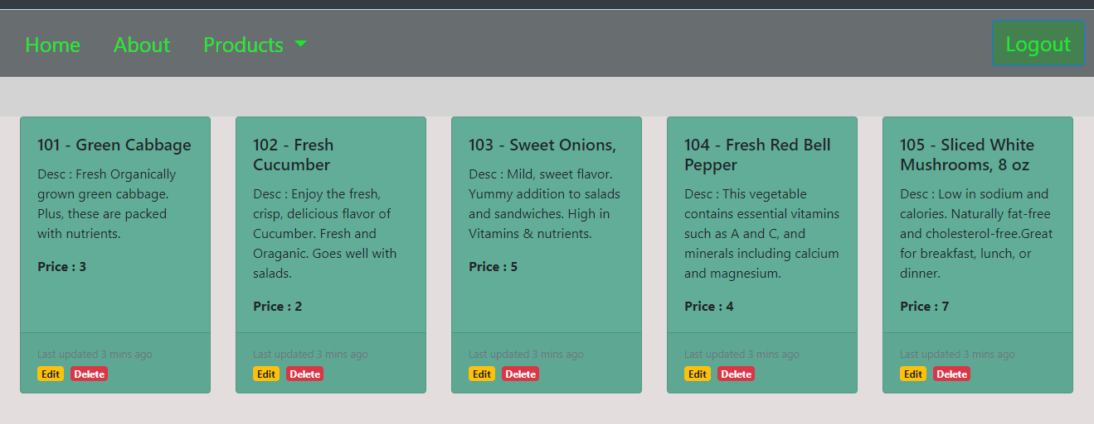

* Upon clicking logoff, successfully logs off and redirects back to login page.

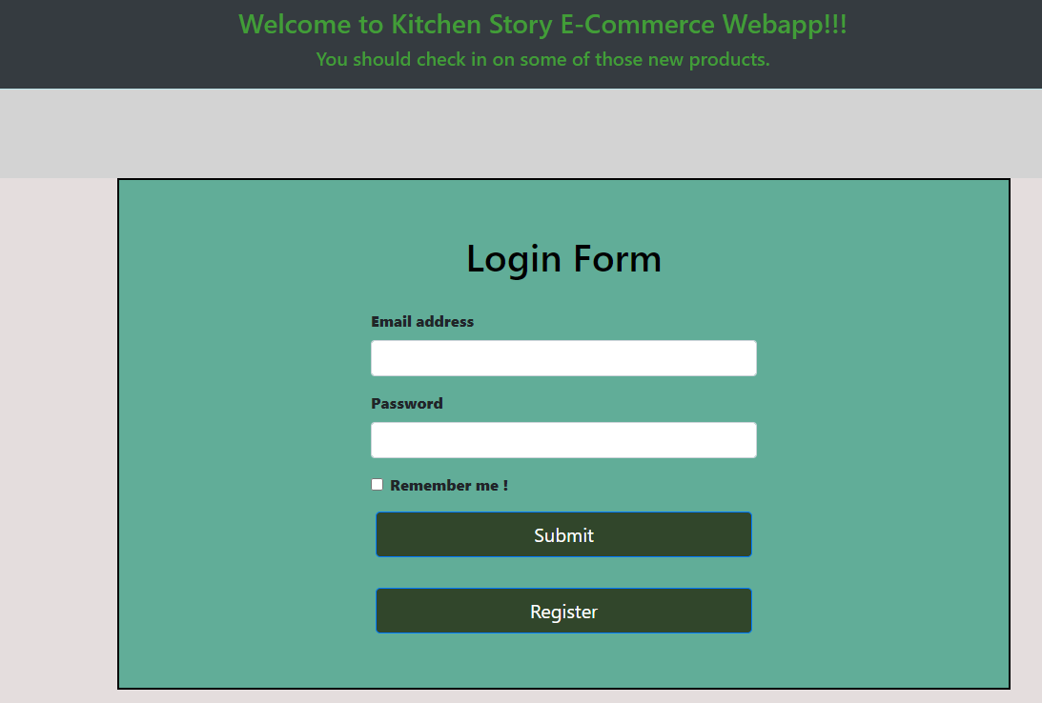

* Buyer registration form validations,

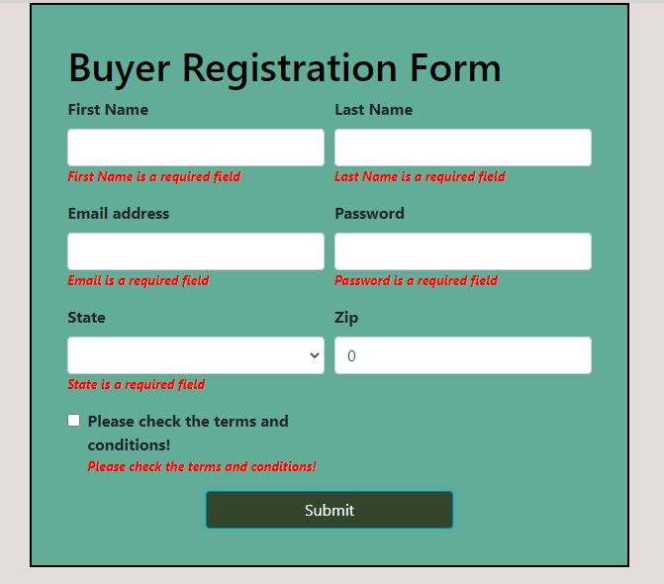

* Register as “buyer” user.

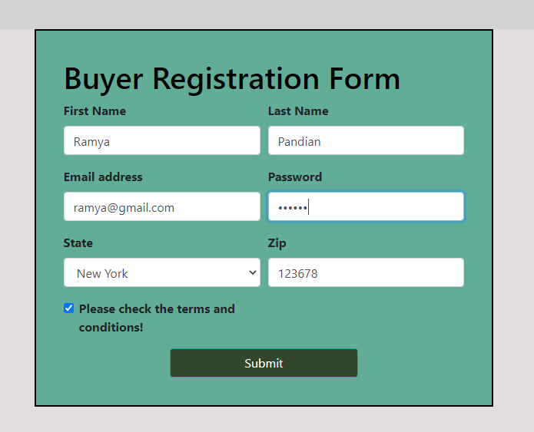

* Buyer login form validations,

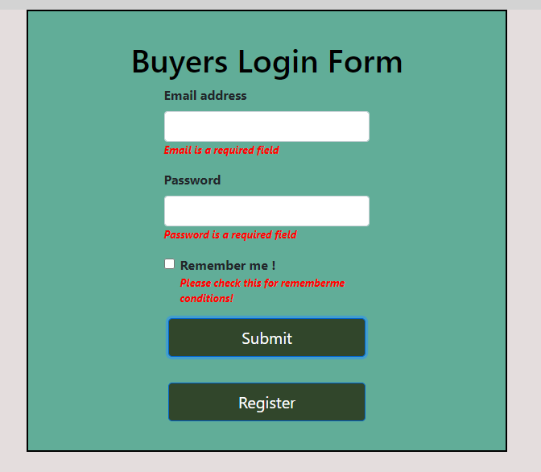

* Buyer logs into the application,

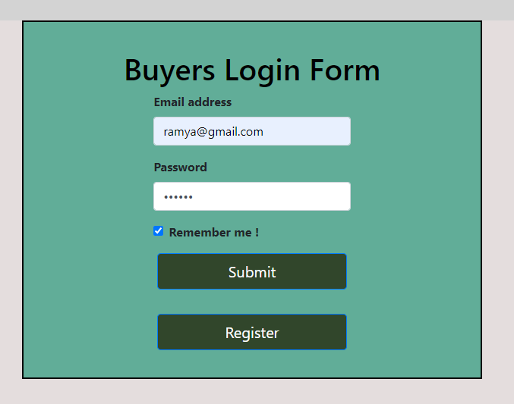

* Buyers home Page,

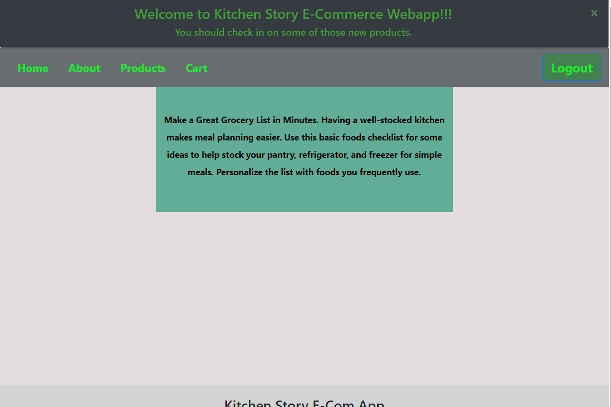

* Admin about Page,

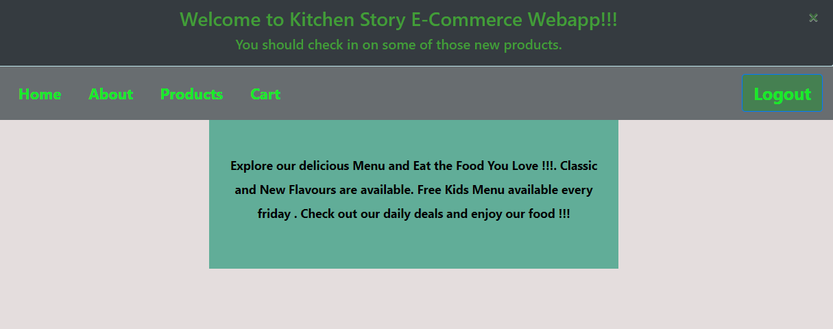

* Upon clicking Product, available list of products is displayed.

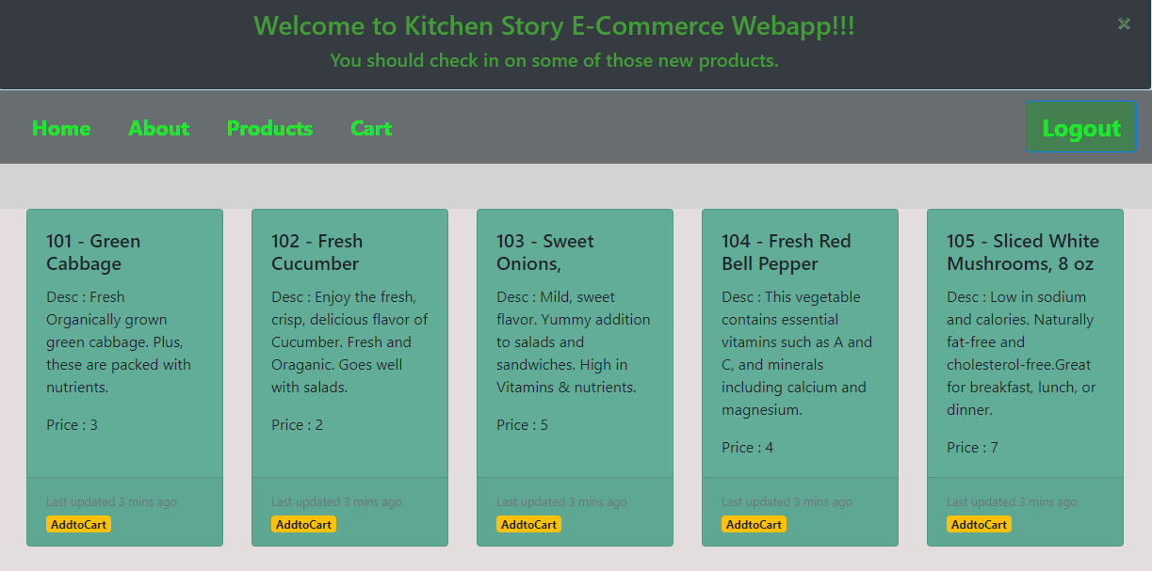

* Search specific product,

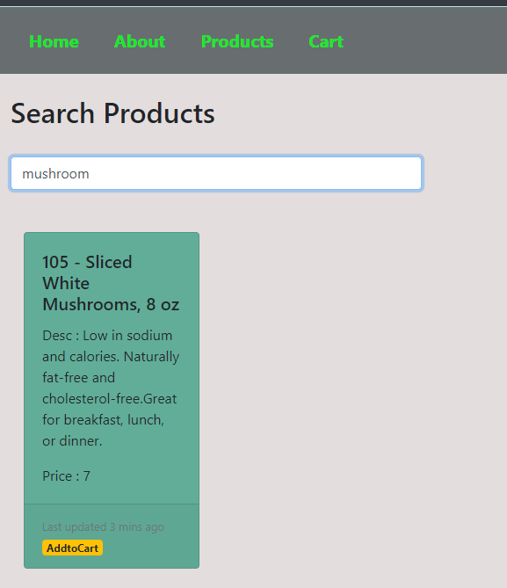

* AddtoCart adds product to cart,

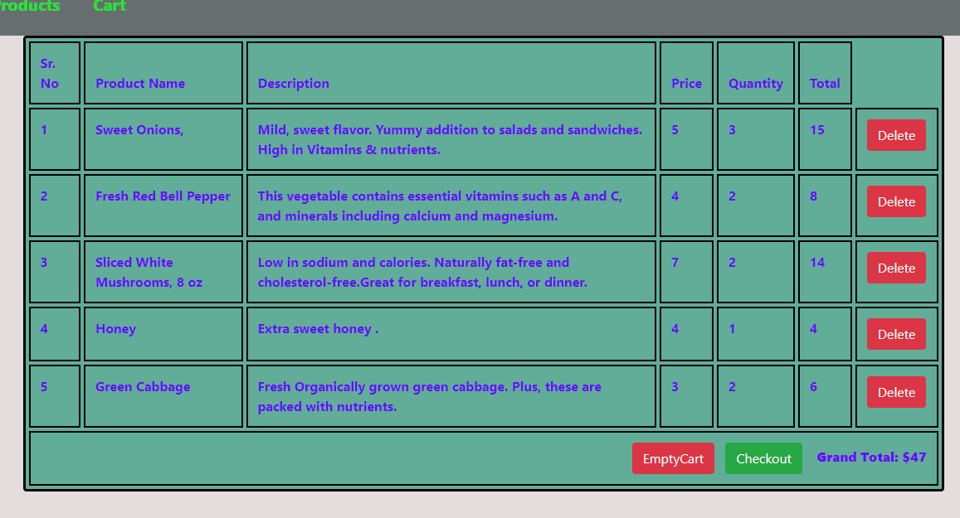

* Upon clicking ‘Delete button’, remove specific item from the cart,

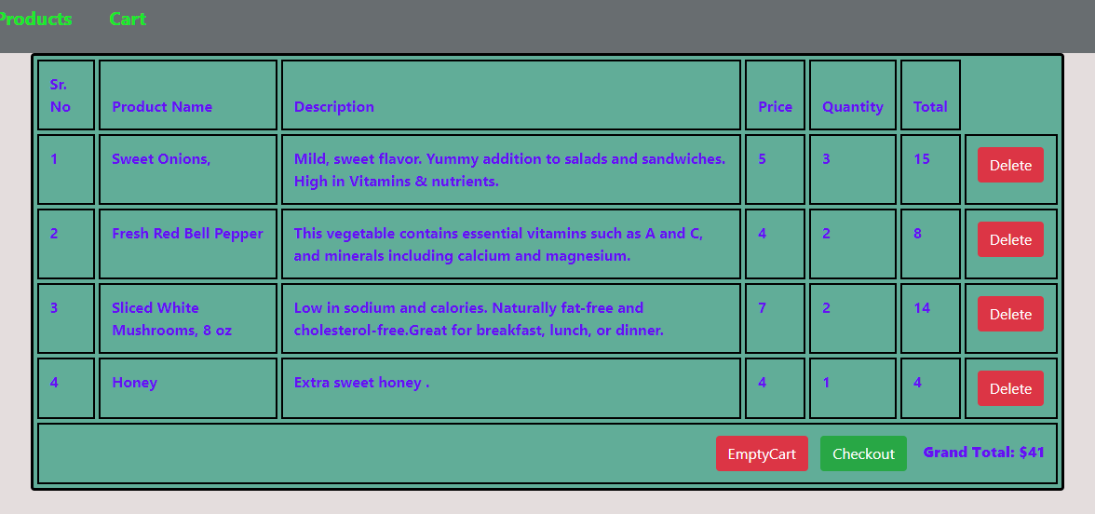

* Upon clicking ‘Empty Cart button’, removes all items from the cart,

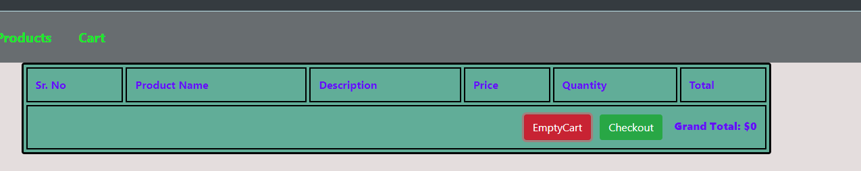

* Checkout cart button, brings up the checkout form with customer and payment details.

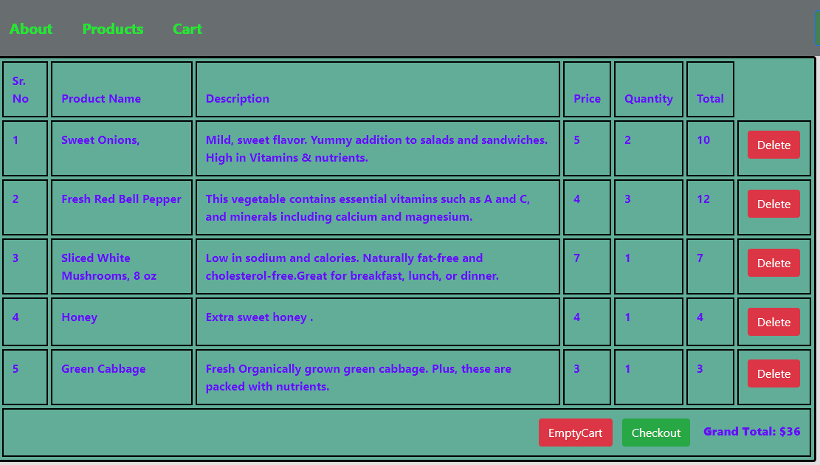

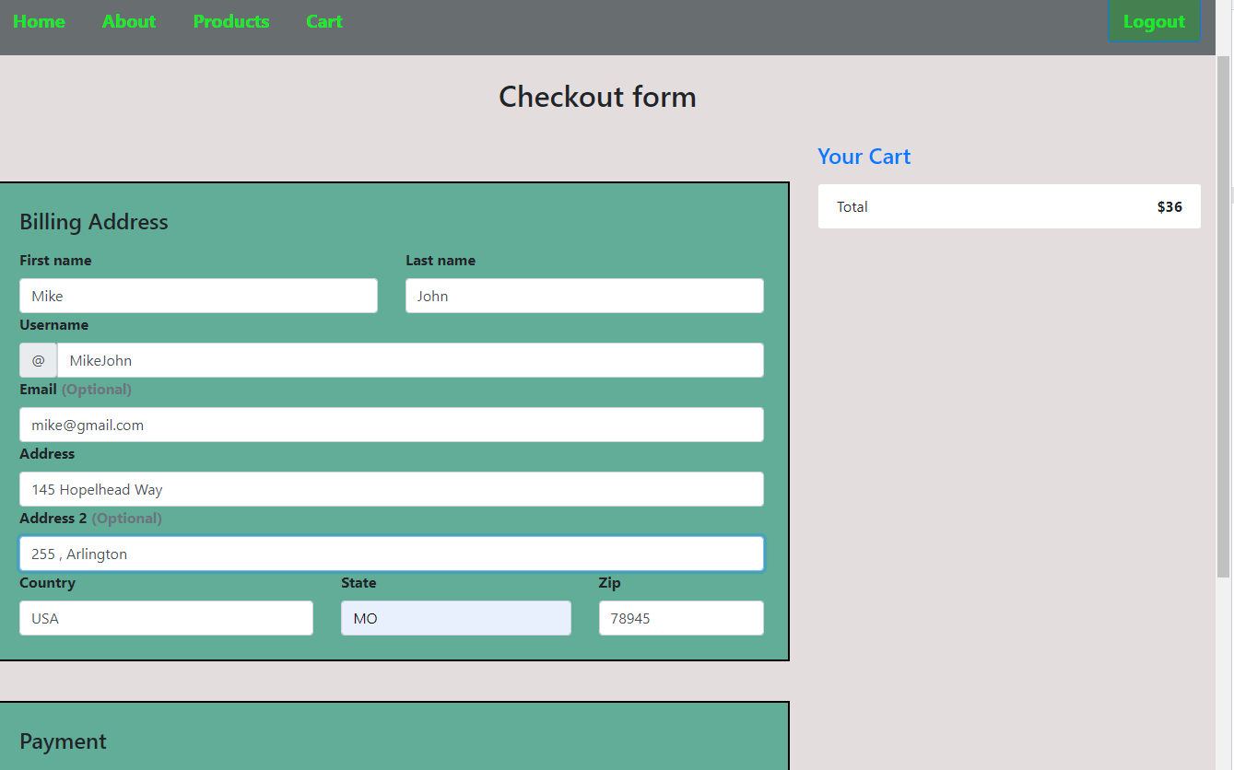

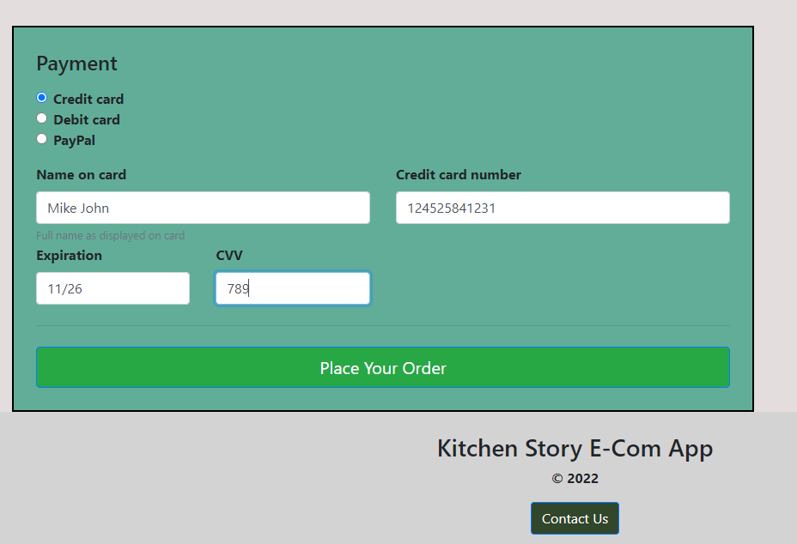

* Upon clicking ‘Place Your Order’ button, below confirmation screen gets displayed.

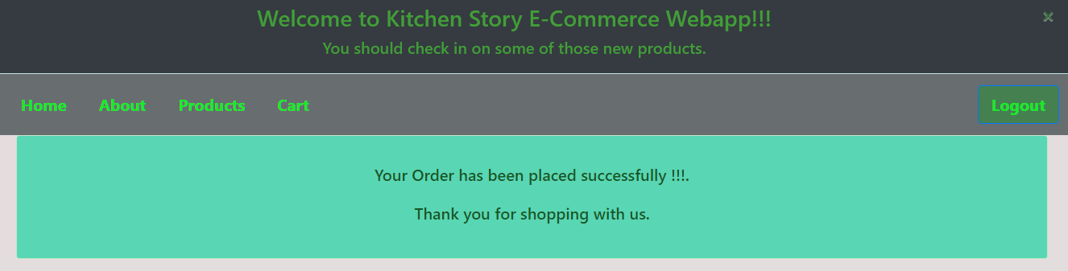

* Upon clicking logoff, successfully logs off and redirects back to login page.

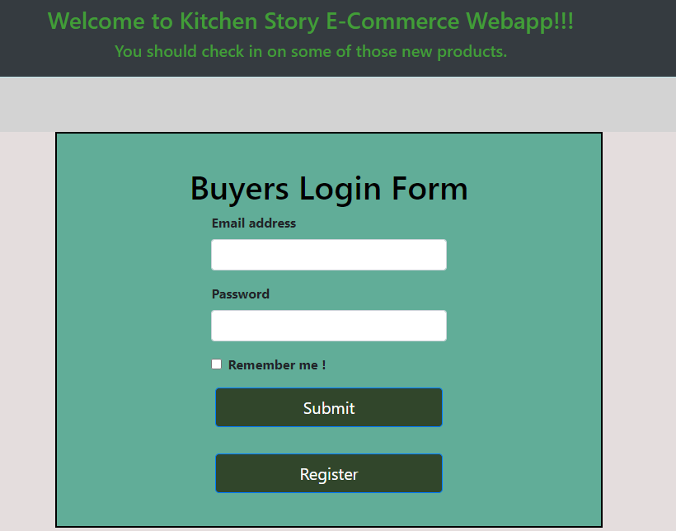

## **Pushing the code to GitHub repository**

* Open your command prompt and navigate to the folder where you have created your files.

**cd <folder path>**

* Initialize repository using the following command:

**git init**

* Add all the files to your git repository using the following command:

**git add .**

* Commit the changes using the following command:

**git commit -m <commit message>**

* Push the files to the folder you initially created using the following command:

**git push -u origin main**

**Source code for the project available under below repository,**

<https://github.com/S-KAVITHA/Phase-4-Kitchen-Story-Project>